FRSKY Telemetry – A simple guide using Smartie Parts and the Sparkfun Adaptor
To run the FrSky build of er9x you will need to make some modifications to the hardware in your radio and telemetry receiver. These modifications require soldering of small tracks on the radio circuit board. Be warned that it is possible to damage the board permanently if care is not taken!
This guide has been put together to try and consolidate all information on this conversion into one simple to use guide.

Note! Large portions of the text have been lifted from various other sources. Full credits for all of this work go to the countless people on the forums who have put together such a good system.
To do this mod you will need the following:
Sparkfun RS232 TTL Convertor:
http://www.sparkfun.com/products/8780
Smartie Parts Add On Board
http://www.smartieparts.com/shop/index.php?main_page=product_info&cPath=3&products_id=331
2 x 220ohm resistor
http://shop.ebay.co.uk/i.html?_from=R40&_trksid=p5197.m570.l1313&_nkw=220ohm+resistor&_sacat=See-All-Categories
Some Single Core insulated cable. IDE Ribbon Leads work well!
http://shop.ebay.co.uk/i.html?_nkw=ide+ribbon+cable&_sacat=0&_dmpt=UK_Computing_CablesConnectors_RL&_odkw=ide+cable&_osacat=0&_trksid=p3286.c0.m270.l1313

Step 1
This is by far the hardest part of the job, and extreme care should be taken to avoid damaging your tx permanently!
Referring to the image below ...
- Remove the two left-hand-most resistors as indicated in yellow
- Hot glue a couple of 220ohm resistors (1/8th or 1/4watt are OK) to a nearby, clearish area of the PCB
- Solder your 'super fine' wires to pins 41 and 42 of the ATmega and connect to the top end of the resistors as shown. Use alcohol if required -- to steady your hands! (Just joking -- but if it works for you -- go right ahead. :p)
HINT: Pre-solder the wire end and the ATmega pins. Use a solder sucker or de-soldering wick to clear away excess solder from the two pins and to remove any solder bridge. Then lay the first wire end over the pin and apply the soldering iron directly down on top of it for half a second, then directly straight up -- then let go the wire. Give the wire a gentle tug in the direction directly away from the chip (in line with the pin).If it holds -- you're done. Don't futz with it. If you're right handed, solder the left hand wire first, so the the soldering iron does not lay over the first wire when trying to solder the second.
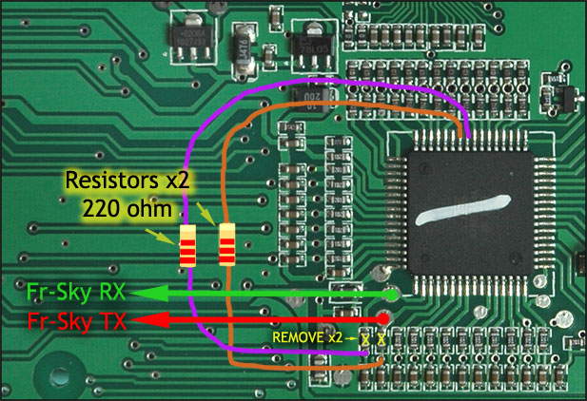

NOTE: It pays to use small dabs of hot-glue near the ATmega pins and in a couple of places along the wires to hold them in place. The last thing you want is for something to get hooked under them and rip them off, possibly damaging the ATmega pins in the process!

Step 2
Install the smartieparts board. This job is so simple that there is no need to duplicate information in this document. Infact, chances are you have already at this point installed one before contemplating this mod!
For reference, a comprehensive guide for this install can be found on:
http://er9x.googlecode.com/svn/trunk/doc/9x-addon-instructions.pdf
The end result will look something like the image below:
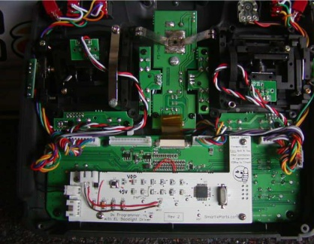
Note! At this point it is worth taking a look at the board and making note of the labels that have been kindly printed on it. Namely MISO, MOSO, 5V and GND. These will all be used when plugging in the RS232 Convertor!

Step 3
This step uses the Sparkfun RS232 convertor, and could not be simpler!
You will needs to get yourself one of these: http://www.sparkfun.com/products/8780
And then take note of the following connections that you will need to solder up. Each of these runs from the Sparkfun Adapter to the labelled pad on the Smartie Parts board.
RX-I -> MISO
TX-O -> MOSI
VCC -> 5V
GND -> GND
In addition you will need to wire these two pin ours from the sparkfun adaptor to the DHT/frsky module.
The DB9 connections are:
Pin 2 (RS-OUT) -> Frsky Rxd (view note below)
Pin 3 (RS-IN) -> Frsky Txd (view note below)
The following image will show the end result!
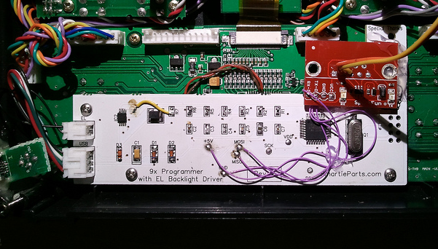
Note! In the image above, pin 2 is the red cable and pin 3 is the yellow.
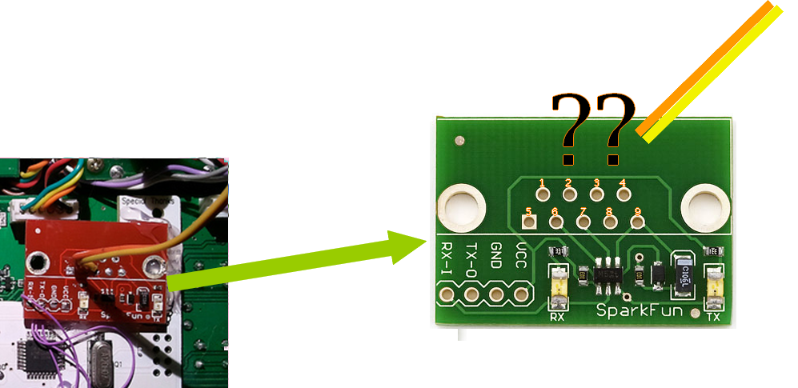
Note! Some of the Sparkfun modules seem to have been shipped with numbers printed on the pins. These seem to be marked differently to standard, and pin 2 is labelled ‘6’ and pin 3 is labled ‘7’. This is shown clearly in the image above:
If this is the case simply use these mappings:
The DB9 connections are:
Pin 6 (RS-OUT) -> Frsky Rxd (view note below)
Pin 7 (RS-IN) -> Frsky Txd (view note below)

Step 4
This is the easy part. Close the tx up, load the firmware and pray all works! The good news is that you will know pretty quickly if the telemetry is working, because the frsky page on the er9x firmware will have loads of data on it showing signal strength and alarms.

